NAME:MEGHANA GANESH
REG NO:210905160
ROLL NO:26
CSE A

Dynamic NAT

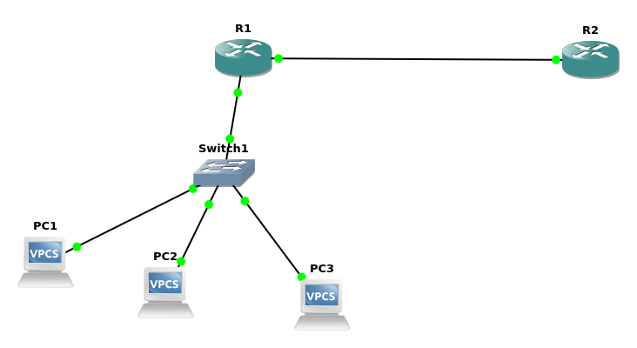
R1:

conf t

ip nat pool cnlab 200.0.0.1 200.0.0.9 netmask 255.255.255.0

access-list 1 permit 192.168.0.0 0.0.0.255

ip nat inside source list 1 pool cnlab

int f0/1
ip address 192.168.0.254 255.255.255.0
no shut
ip nat inside
exit

int f0/0
ip address 200.0.0.1 255.255.255.0
no shut
ip nat outside
exit

R2:

conf t
int f0/0
ip address 200.0.0.10 255.255.255.0
no shut
exit

PC1:

ip 192.168.0.1/24 192.168.0.254

PC2

ip 192.168.0.2/24 192.168.0.254

PC3

ip 192.168.0.3/24 192.168.0.254

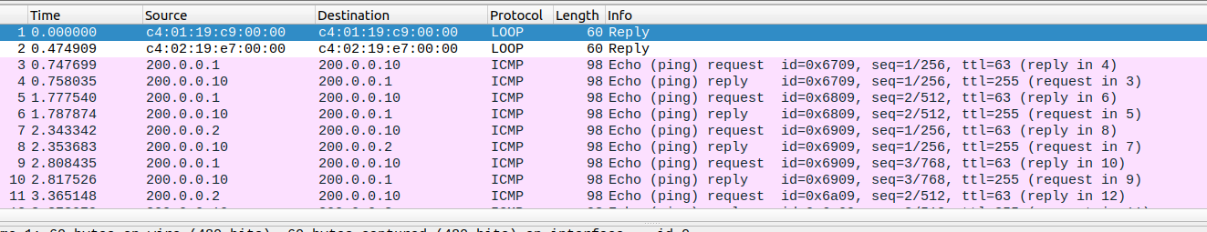
We can see that, when ping requests are sent simultaneously, the public IP address is selected from the NAT pool.

